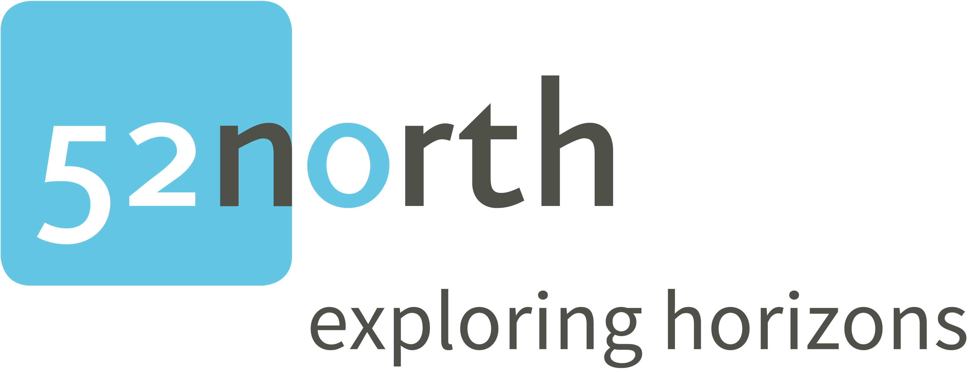

Personal declaration to accompany my application for the
52°North Student Innovation Challenge 2018

Name:

Date of birth:

Address:

Telephone:

E-mail:

University/College:

Subject:

Highest completed degree (e.g. Bachelor):

Semesters or years:

I hereby declare that I recognize the following conditions of the competition and the awarding of the 52°North Student Innovation Challenge 2018:

- I am the original author and copyright owner of the ideas and concept outlined in the paper submitted.

- The decision of the competition's organizers is final and no correspondence will be entered into.

- The granting of the prize will not be deemed as constituting any right to either temporary or permanent employment with any of the prize-awarding organizations.

…………………………………………. ……………………………………………..
Place, date: Signature

